Digital Forensics Milestone 2

- Calculate the hashes:
The hashes do infact match
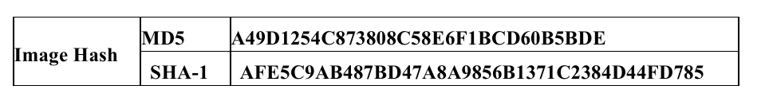
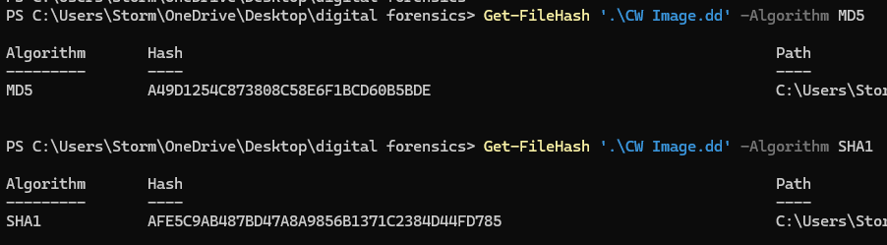

- Analyzing the partition table using a python script
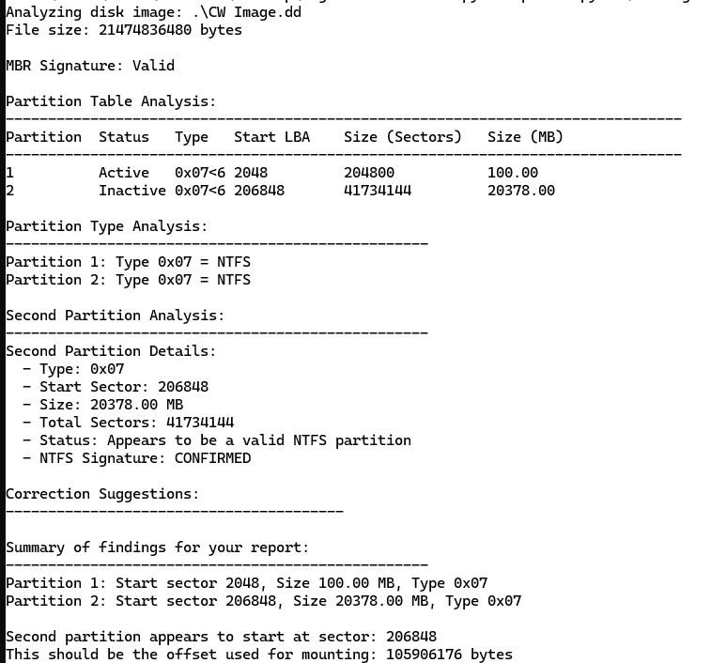
Mounting the image onto the forensic tool (autopsy)
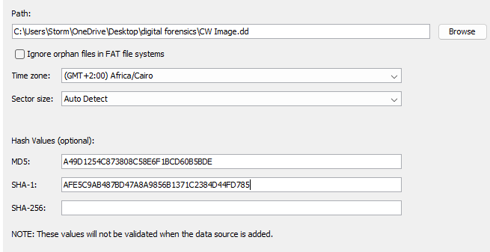
Loading the case file…

Autopsy chain of custody log
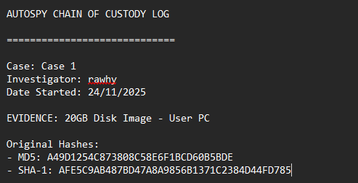

Task 2: Disk Image Analysis
Head over to the second partition from the partition table (the large one) as it has all the files we need
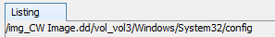
Go to the /Windows/System32/config path to be able to extract the SAM, SYSTEM, and SOFTWARE files
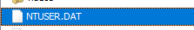
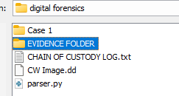
Extract them into your evidence folder

Task 3:
Recovering deleted files
Here we head over to the deleted files in the file tree
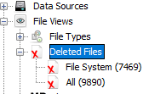

Recovering all deleted files:
Then putting them in our evidence folder
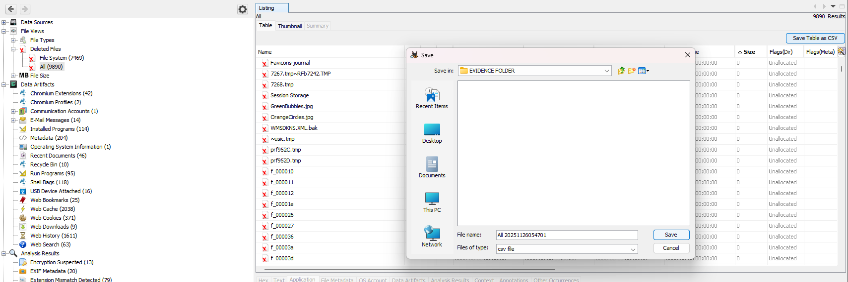

Check for suspicious files:
Files created and modified in 2076
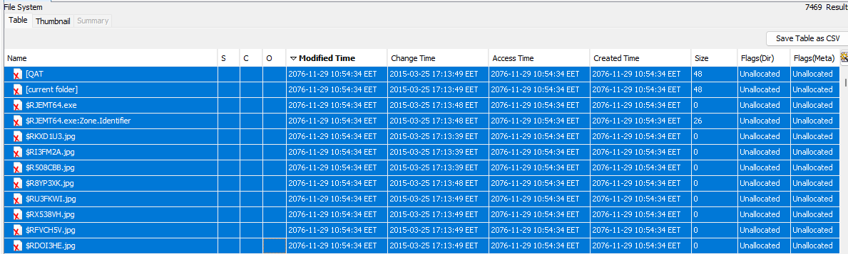
Unexpected executable files in extremely large sizes
Another suspicious file

Looking for browser history
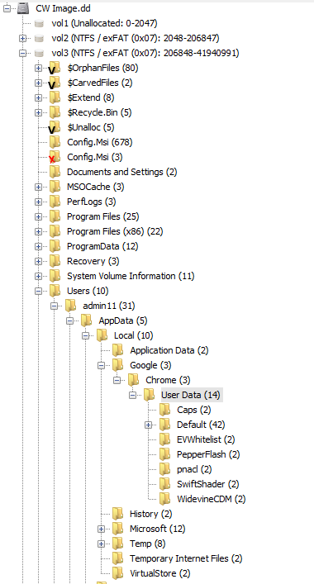
Through internet explorer aswell
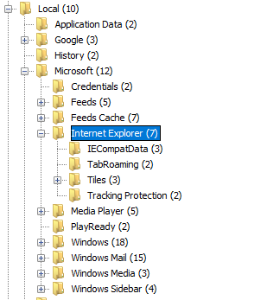
Here is a complete list of the browser history
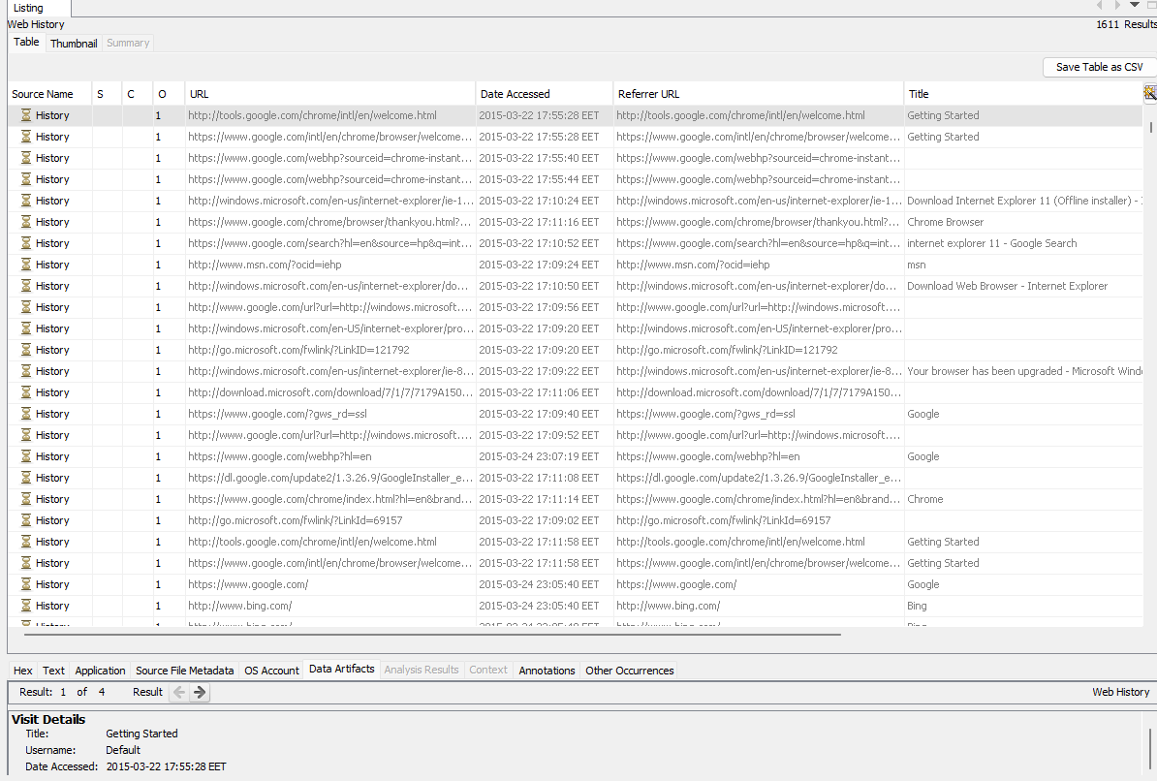
A whole list of secret email messages
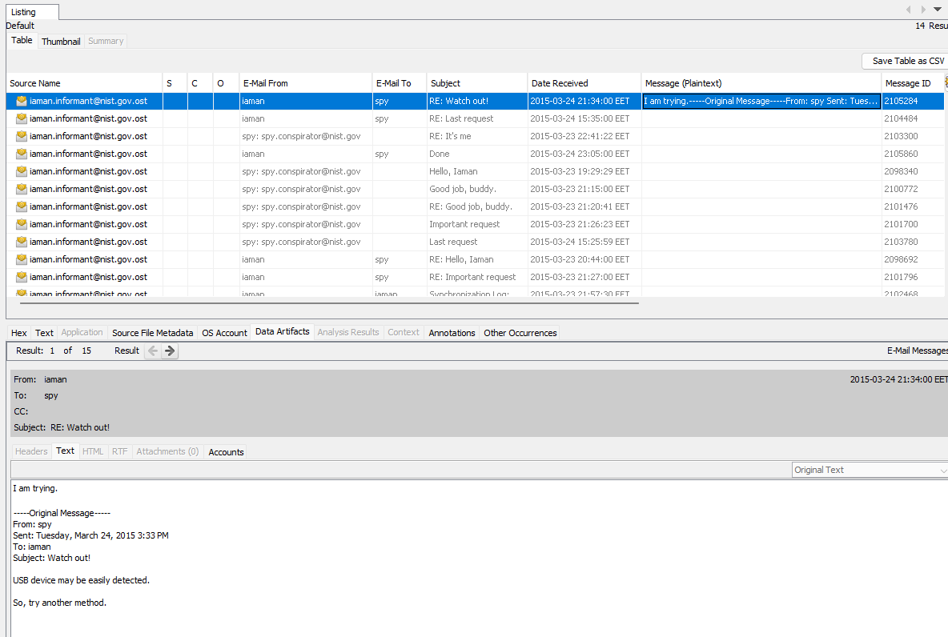

Documentation:

Used autopsy to read the disk image and discover everything needed
Created a chain of custody that keeps records of everything done in detail
Created 2 python scripts
One python script to parse the partition tables
And the other python script was to analyze and generate a forensic report.

